**Section 9 done: 18/18 Reaching out to the Web (Http / Ajax)**  
**Introduction**  
* React is a library which allows you to create the Front End of your application. Basically the HTML code, the code running in the browser. And if you’re creating a single-page application - something you’re often doing with React, then you have an even more decoupled application, more decoupled from your Back End.  
=> Therefore it’s of course important to understand how you can actually send HTTP or since we have the decoupling going in - AJAX requests specifically - from your React Front End from your JavaScript code to your Server-Side Back End.  
**Understanding HTTP Requests in React**  
* So how does sending HTTP Requests work in React applications typically?   
=> I’m saying typically because if you’re creating a Multi-Page React application, there actually isn’t anything special to it - you probably have your application, your page, where you submit a form and that sends a request to your Back End and you get back a new HTML page with potentially new React code in there. You don’t have a Single-Page application, you don’t have strong decoupling going on.  
=> If you have a Single-Page application, you have a strong differentiation between your Front End, your React app and your Back End.  
=> The React app and the Server still need to communicate from time to time but they don’t communicate by exchanging HTML pages. So if a React app sends a request to a Server, you don’t get back a new HTML page, instead, you get back some JSON Data typically. Or you send some JSON Data to the Server, if you want to create some resources on the Server.  
=> And your Server therefore typically is a RESTful API - just exposing some API End Points to which you can send Requests to get or send Data from your standalone React application.  
**Understanding our Project and Introducing Axios**  
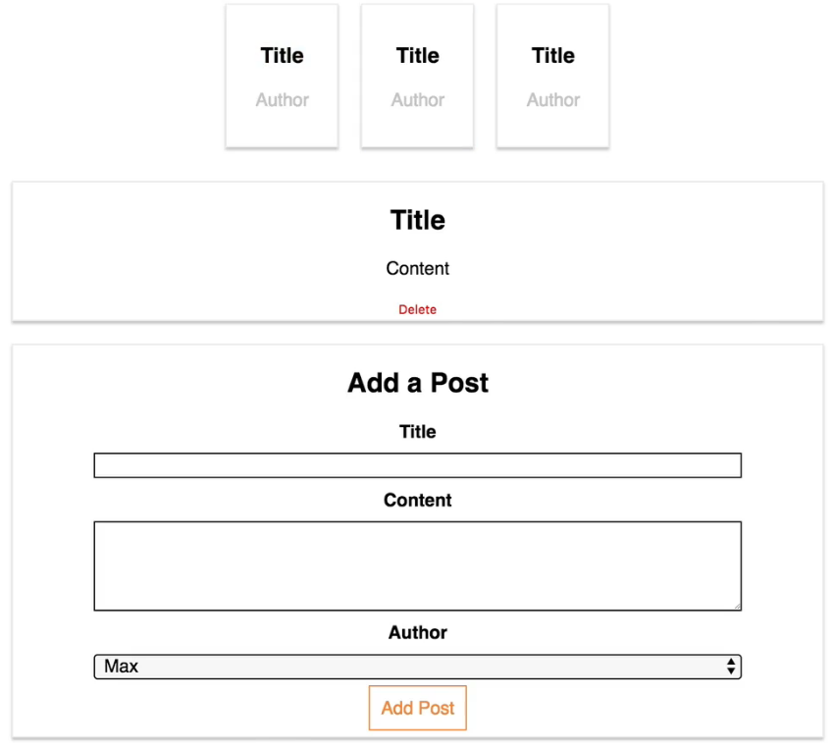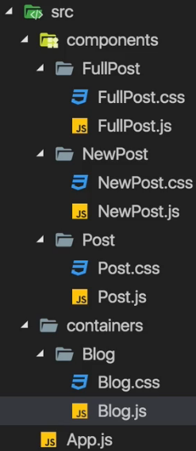  
* In here we’ll use <https://jsonplaceholder.typicode.com> instead of a real Server. Which simply is a RESTful API Back End where you can send requests to to fetch some dummy Data or to simulate storing some dummy Data there though you won’t actually store something, it’s just faking some Data.  
* We need some way of sending these AJAX Requests. And here you have basically 2 options.  
=> JavaScript of course has the XMLHttpRequest object. With that you can construct your own AJAX Requests and send them to a specific URL and handle the Response. Nothing wrong with that. Since React is just about writing JavaScript everywhere, you can of course use all the JavaScript features, including XMLHttpRequest. But writing and configuring a Request with that object manually is quite cumbersome.   
=> So the second option is to use a package, a Third-Party Library which makes that easier. And for that I recommend using **Axios**. You can add Axios to any project, not just React.  
**npm install --save axios**  
**Creating an HTTP Request to GET Data**  
* Where do we make this HTTP Request then? Let’s take a look at Lifecycle Hooks.  
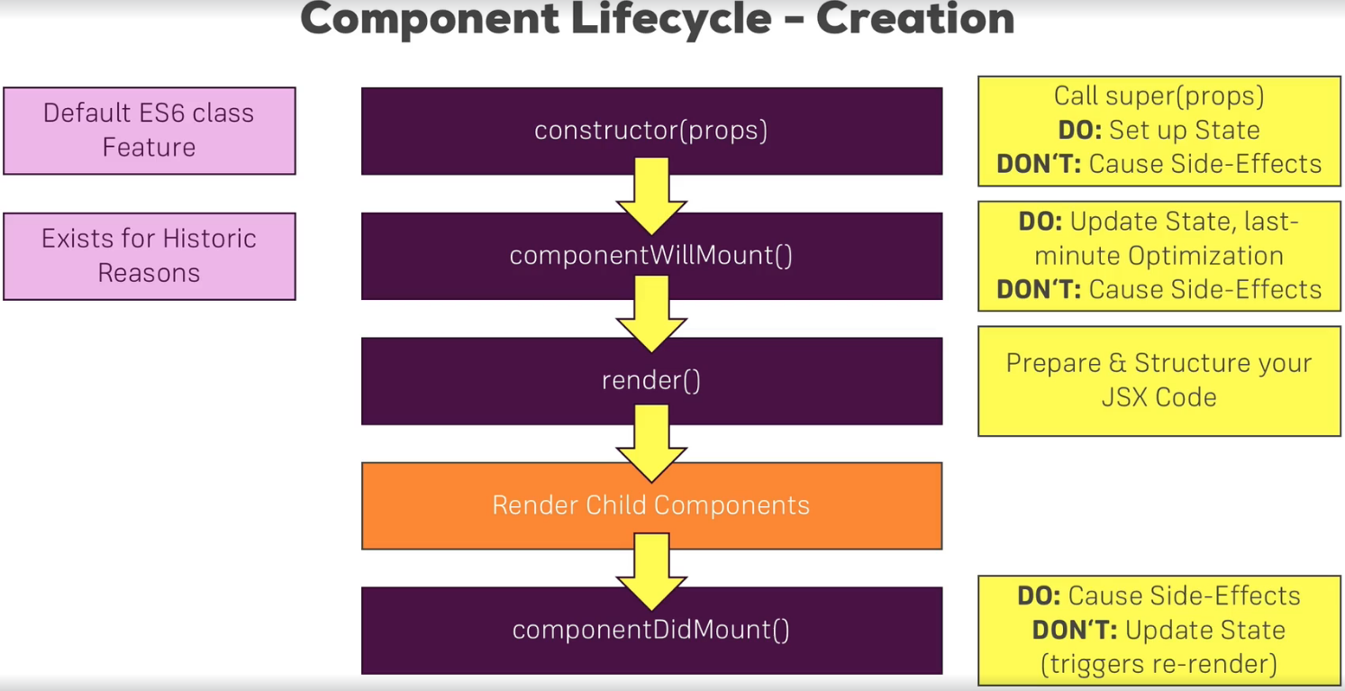  
=> In **Component Creation**, there’s 1 Lifecycle we should use for **Side-Effects**.   
=> **componentDidMount()**.  
* The HTTP Request is a Side-Effect, it doesn’t affect your React logic or something like that but it has the Side-Effect of fetching you Data. And if your React application is dynamically outputting some Data which it probably is, the Data changing of course is a Side-Effect affecting your application.  
=> So componentDidMount() is a great place for causing Side-Effects but not for updating STATE since it triggers a re-render. We will still update the STATE here once the HTTP Request is done and got us new Data because we actually want to re-update the the page. So here this is actually a wanted behavior.  
=> So componentDidMount() is the best place to send the HTTP Request.   
  
* **axios.get(“”)** => this method needs at least 1 argument - the URL we wanna send the Request to. Now you can also pass a second argument to configure this Request and you can learn all about it on its GitHub page.  
* This should return us some posts but trying to store them in a post constant won’t work because of course that GET Request happens asynchronously, it doesn’t finish immediatelly, it needs some time to go to the Server and GET the Data. JavaScript though, executes your code in a synchronous manner, so this line, the next line is executed immediatelly, it won’t pause until this axios.get function is finished, so it won’t store the posts in the posts constant here. This is the wanted behavior because we don’t want to block the execution of our application just because we’re waiting for this GET Request to finish.  
=> Axios therefore uses **PROMISES**, a **default JavaScript object, introduced with ES6** and thanks to our workflow we’re using with create-react-app also available in older browsers since the code gets compiled to code which also works in older browsers.  
=> So Axios uses PROMISES and axios.get() returns a PROMISE.  
=> So we can chain **.then()** on it. It’s simply a method which takes a function as the input and this function **will get executed once the promise RESOLVES**. So once the Data from the Back End is there we can say. The function then receives a **response** object as an input. This will be passed into the function automatically by axios.  
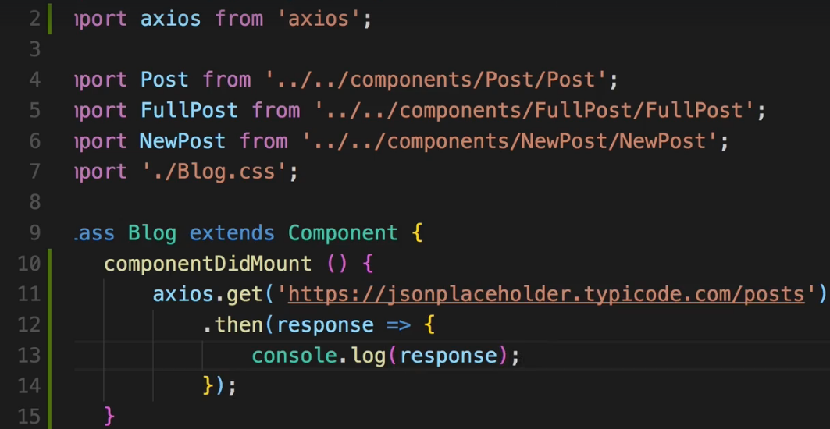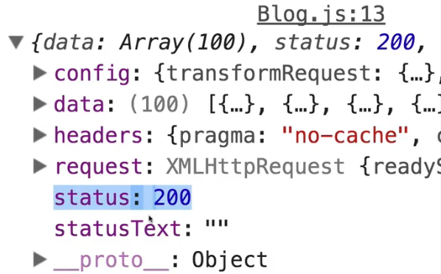  
=> All these properties here are just properties provided by the Axios package. So we got the status code 200 so it was successful, we see the Request which was sent, we see the Response Headers and important for us - we got that `**data**` object which contains the Data returned from the Server we sent the Request to.  
* And I wanna work with that Data to render dynamically to the screen here and output some posts instead of that dummy content I have right now.  
**Rendering Fetched Data to the Screen**  
* For dynamically generating the posts we need to manage some STATE of course.  
* And we should have some posts in that STATE, initially this can be an empty array [].  
=> Now I want to update the STATE once we fetched Data from the Server and therefore the place to call this setState() is inside the .then() method. If we called it outside of this, so after the axios.get() method, we wouldn’t have the posts yet because JavaScript doesn’t wait for it to finish.  
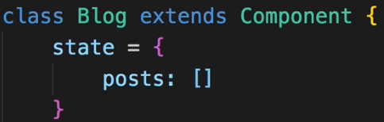  
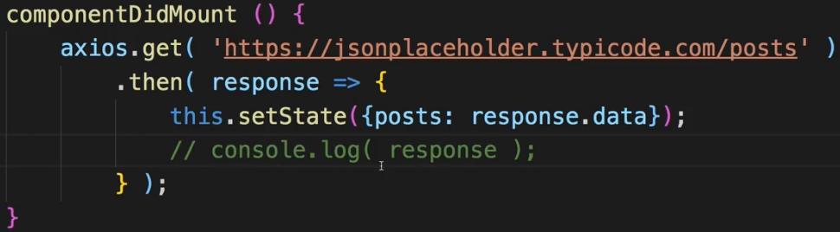  
* Now let’s output our posts dynamically in the rende() method.  
=> For that I’ll create a new constant here. And that should be an array of JSX elements.  
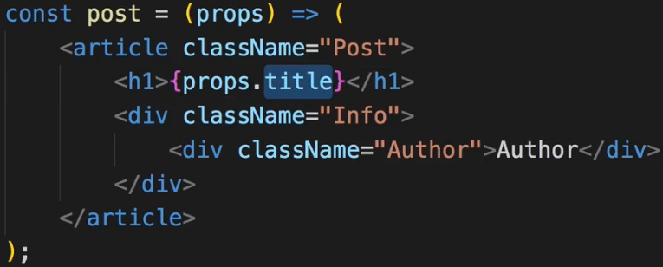  
* In Blog.js:  
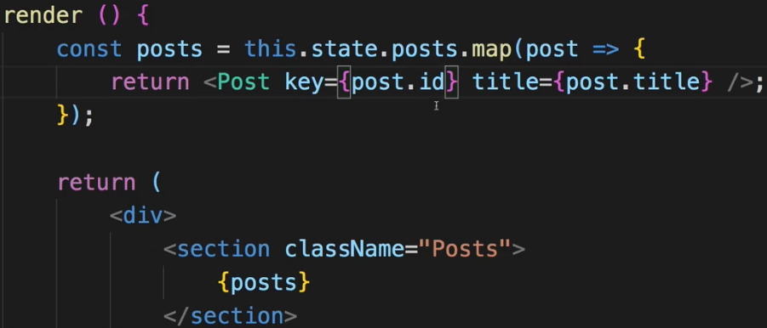 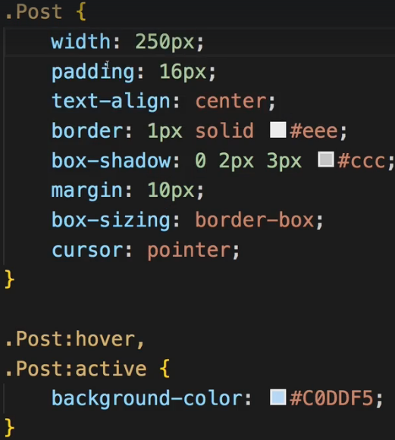  
* Styling is a bit off now and we also output all the posts which might be too much - we’ll take care of that next, I’ll show you how to transform the Data you get back.   
**Transforming Data**  
* Now for a real application you probably can send some **QUERY PARAMETER** to your Back End to restrict the amount of data you wanna fetch - some **PAGINATION** basically. But of course we can also transform the Data once we got it.  
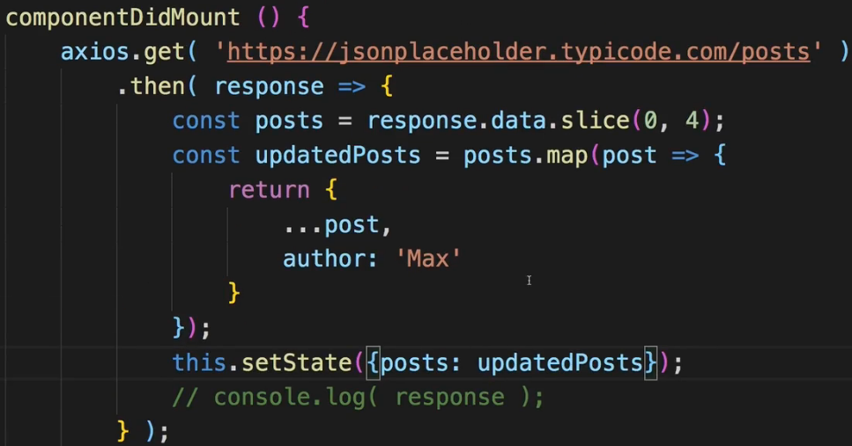 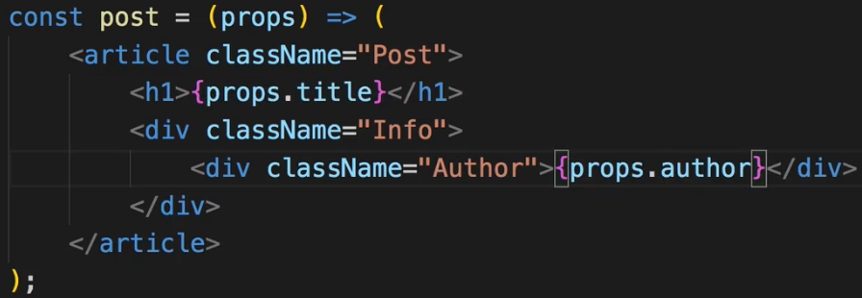  
* We fetch them all but only store 4 of them in the posts constant.  
=> **Limitting the data we fetch with .slice()**.  
* I create an updatedPosts because I also want to add an author field to my posts. Now typically, you would of course also get this from your Back End but our fake Back End doesn’t have it.  
=> **Adding a new property/data to the Data we fetched**.  
* This is just 1 example transformation to showcase that you can of course work with the Data you get back before setting it to the STATE.  
**Making a Post Selectable**  
* Let’s now see how we can make sure that we can CLICK on one of these posts and then LOAD the post Data there.   
=> So fetch the Data for the selected post when we select it.  
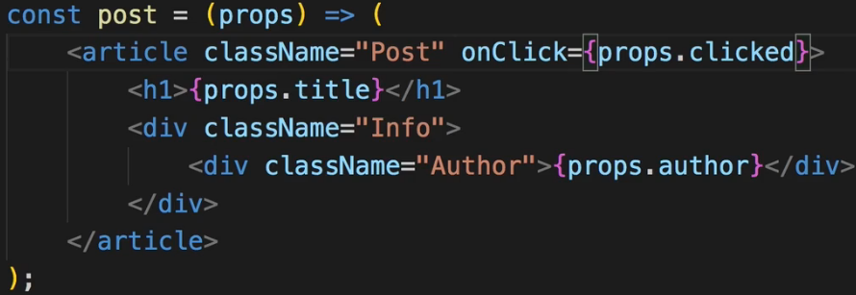 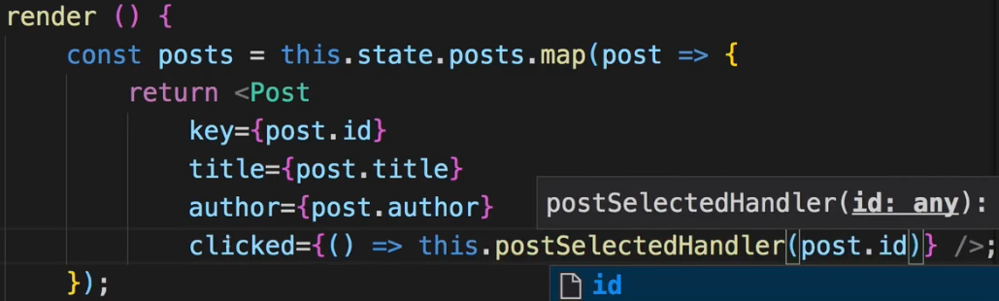  
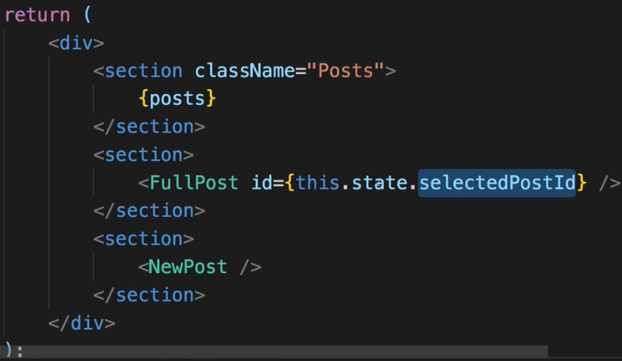 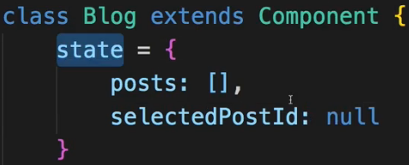  
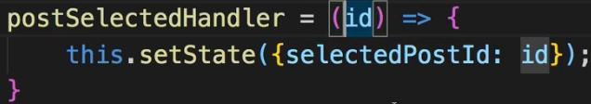  
=> Now where we render the list of posts - **in the `clicked` argument I can pass an ES6 function, arrow function, as a reference which should be executed when we click on a post. And there I want to execute the postSelectedHandler(), BUT now I can pass post.id as an argument to that method. So now I got an ID to work with**. Now that ID should be passed to the <FullPost /> component. So we should probably store it in the STATE on maybe the selectedPost property so that inside FullPost we can listen to us getting a new ID and then fetch Data for that ID.  
=> So now we’re passing that ID to the FullPost component. Now we do something with it there.  
=> There first of all we can use the ID to output either “Please select a Post” or the selected post depending on whether we have an ID or not.  
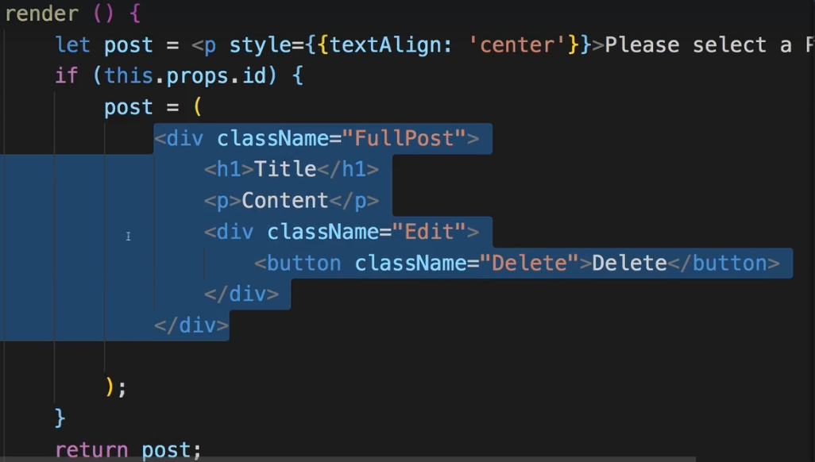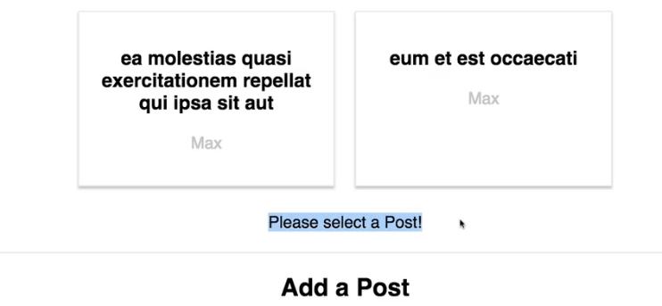  
**Fetchind Data on Update (without Creating Infinite Loops)**  
* Now which Lifecycle Hook should we use here?  
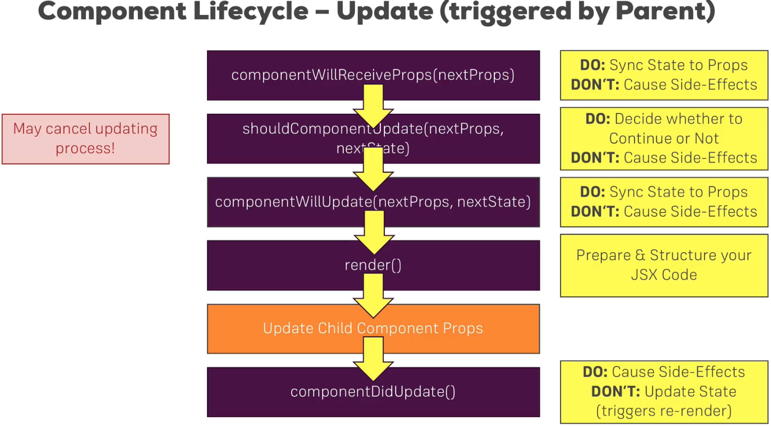  
=> If we have a look at the Lifecycle Hook for Updating Components, and we are of course speaking about the Update Lifecycle Hook because the component is there right from the start. But Data should be fetched once we receive a new prop ID so that is what we’re looking for.  
=> componentDidUpdate() is then a good place for causing Side-Effects. It also has 1 issue though, if we update the STATE in there, we update the component again and we therefore enter an infinite loop. That’s something we’ll have to watch out for.  
* In FullPost.js:  
* We want to output it so we should also manage some STATE in here.  
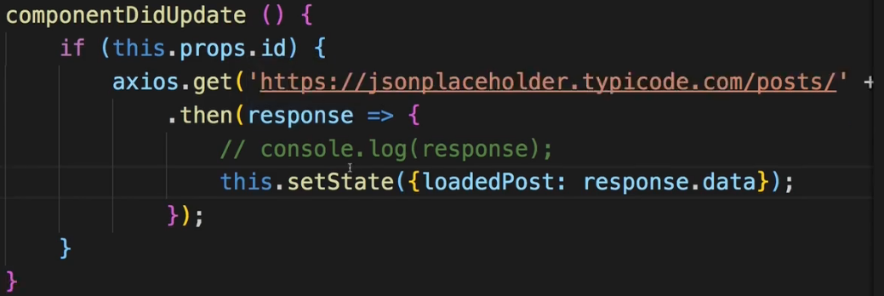 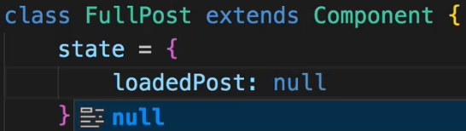  
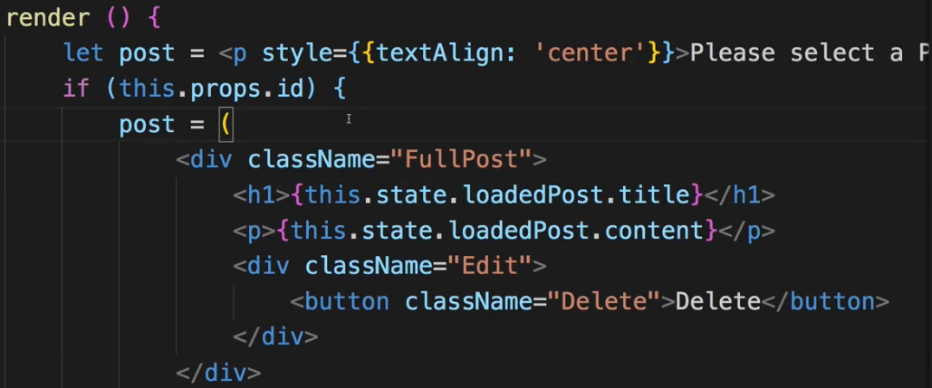  
* Now if we click on a post, we actually receive an error.   
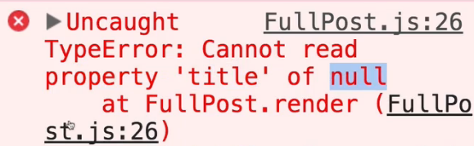  
=> This makes a lot of sense because here in the JSX code for the FullPost, we immediatelly access `**this.state.loadedPost.title**`. And we do this as soon as we got a valid `**this.props.id**`.  
=> Now we get a valid ID before we get a valid post because fetching Data is asynchronous, so first we get the ID and then a little bit later we get the loadedPost but we re-render the DOM immediatelly after we got the ID.  
=> We can simply fix this by adding a check for the validity of the ID as we already have it and say that **in this case, post should actually be a paragraph still but maybe a paragraph where we simply say: “Loading!”, because we selected a post but the Data isn’t there**.  
=> And then in the bottom if statement **we check if `this.state.loadedPost` has been set** because initially it’s null so it will be treated as false but as soon as we got one, this will resolve to true and hence we will render this JSX code.  
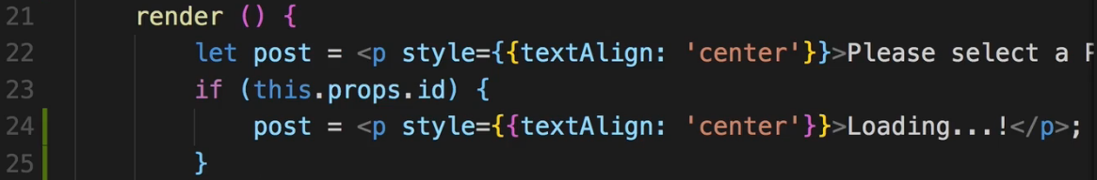  
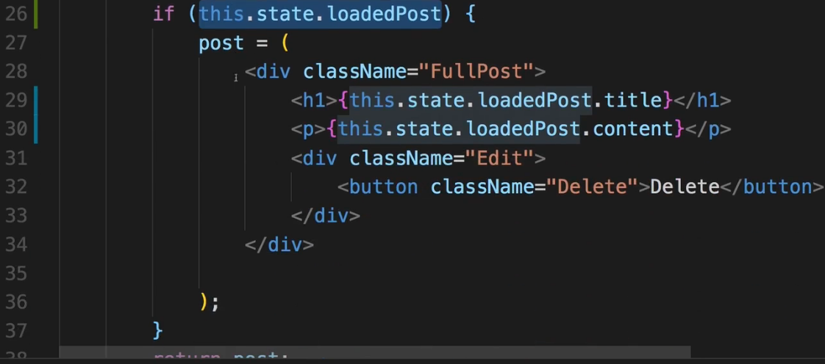  
* Now we see loading for a fraction of a second and then we see the post.   
* We also got an issue here though - if we open the Network tab, you’ll see that we’re re-sending request after request after request… We can simply reload the page to make sure this stops.  
* But why are we seeing this?  
=> **We are seeing these infinite Requests because we’re updating the STATE from within componentDidUpdate() and this creates an infinite loop because when we call setState(), the component will be updated and componentDidUpdate() will execute again**.  
=> So we have to make sure that we only send this HTTP Request and hence update the STATE if we actually loaded a new post. So how do we do that?  
=> We can add an IF check inside the outer IF check here and there we can check if we already have a this.state.loadedPost - so that is the first indicator that we did already load a post.   
=> Then of course we also want to make sure that for this loadedPost, the ID is not the same ID as we just got via PROPS because that would mean that the ID for which we wanna fetch new Data is the ID we already have loaded so we don’t need to make an HTTP Request in this case. So here I’ll check if we have a loadedPost and then if its ID is different than `this.props.id`, then we want to make the Request. In all other cases, we don’t want to.  
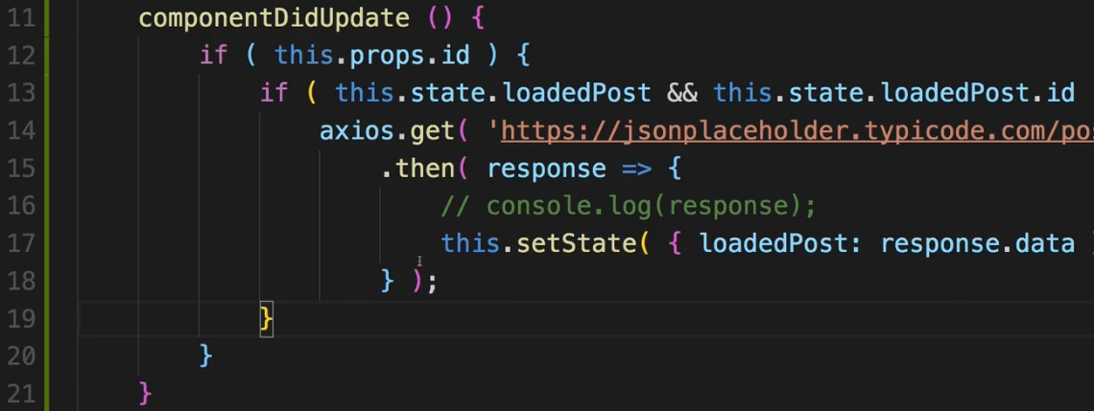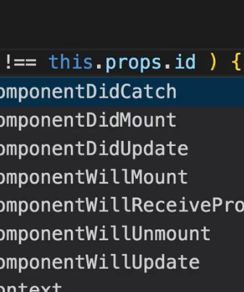  
=> Now we never get the post Data so somehow our check here is failing - well we have to amend it a little bit because initially it will of course fail because loadedPost is null initially.   
=> So this would only succeed if we had at least 1 post loaded.  
=> So I’ll instead check if we don’t have `!this.state.loadedPost` or if we do have it but if it then also has a different ID then the ID we plan on loading.  
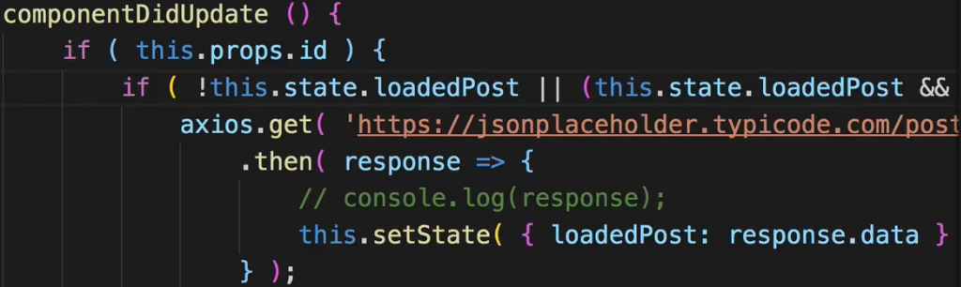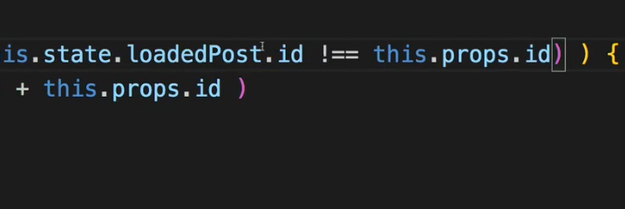  
=> So we go ahead and make the Request either if we have no loadedPost or if we do have one but the IDs are different.  
=> So now we got a way of safely fetching Data in componentDidUpdate() and still componentDidUpdate() is the right place because we wanna fetch Data whenever we receive new props.  
**POSTing Data to the Server**  
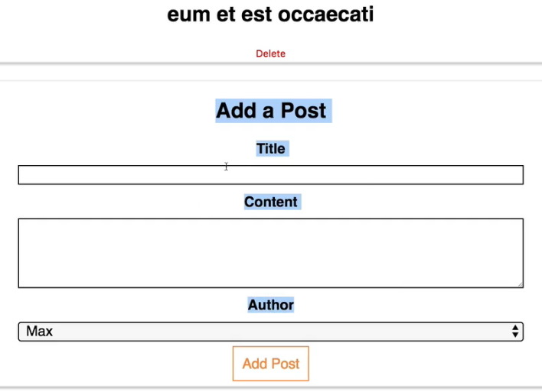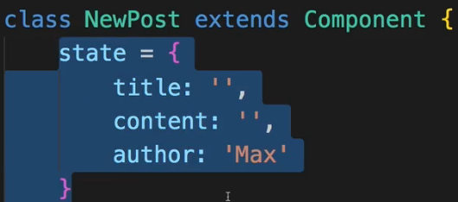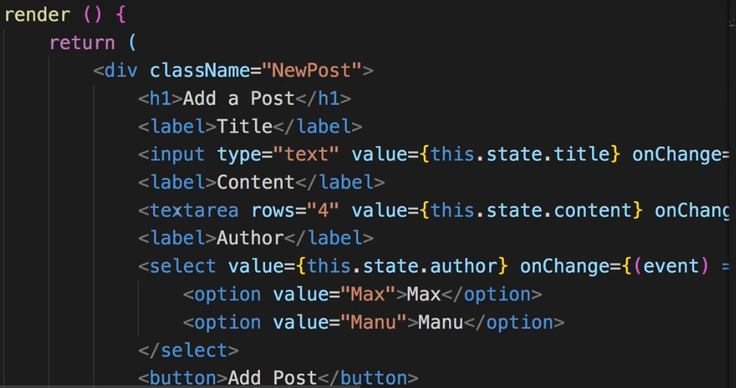  
=> It is a Class-based Component which manages its own STATE and hence isn’t a Container because we’re not passing or distributing the STATE to any other components.  
  
* **axios.post(“”, data)** => it needs a 2nd argument - the data that we wanna send. Now you can also pass a 3rd argument to configure this request.  
* Important for us - the data is of course a JavaScript object but Axios will automatically basically stringify this so turn this into JSON data, it will do this for us, just as it extracted JSON data in the GET Request for us too.  
* And now this of course runs asynchronously, we can listen to the Response just like we can do it for GET Requests.  
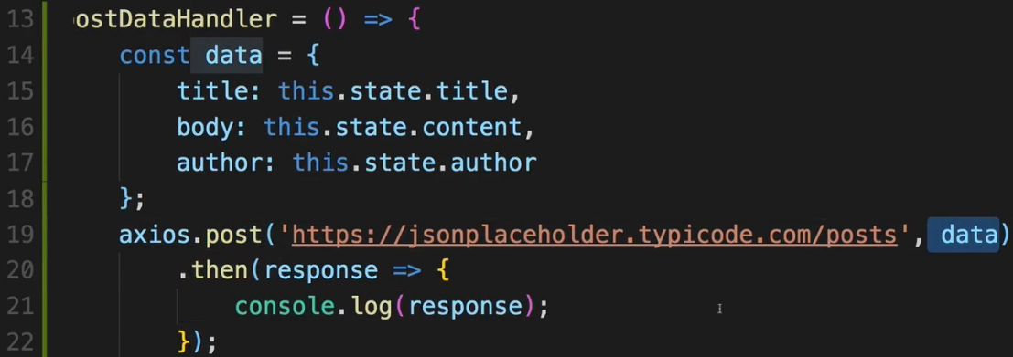  
**Sending a DELETE Request**  
* In FullPost.js:  
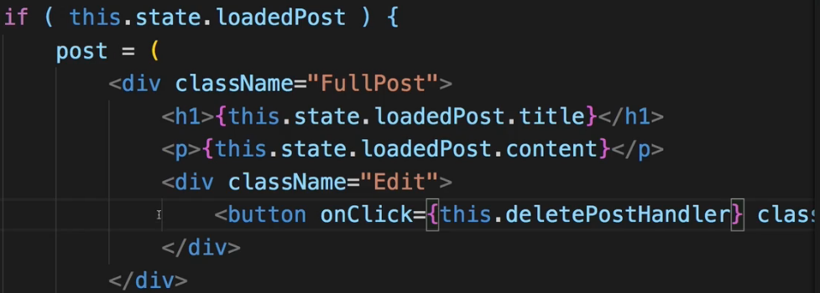 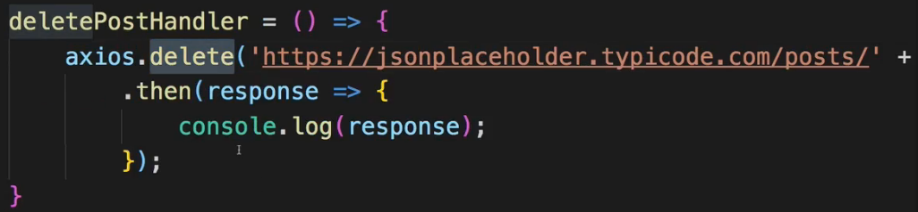  
* We use the same URL as for the update - the ID. And we also get a Response.  
* And of course comparable methods are available for PUT, PATCH and so on.

**Fixing a Bug**  
* We of course don’t see the body here for the chosen post in FullPost component because I tried to load `this.state.loadedPost.content`, but `**this.state.loadedPost.body**` would be correct.  
  
**Handling Errors Locally**  
* Requests don’t always succeed, you also need to know how you may handle errors.  
* Handling Errors is super simple with Axios.  
* You can handle Errors in the way I’m going to show you now, for every type of Request you send.  
=> If we use postssss in the URL, we get this error, it’s unhandled:  
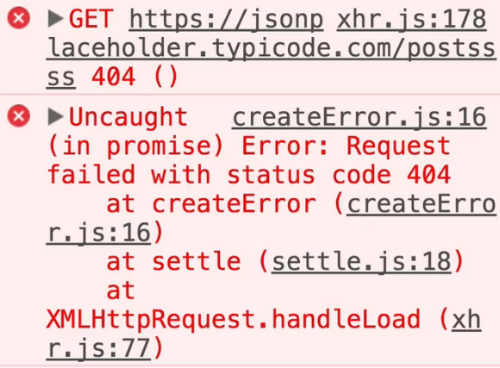  
* We of course want to handle it.  
* Now since Axios uses PROMISES, we don’t only have the .then() method we can chain but we can also add a second method - simply chain it after .then() and that’s the **.catch(error => {})** method.  
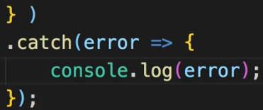 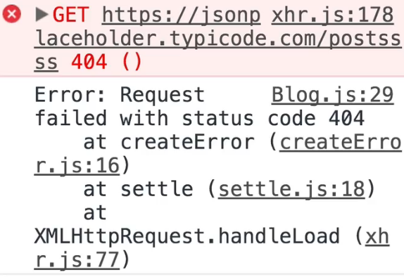  
=> Now the request of course still fails but now the Error is handled and here I’m simply printing this Error: Request with console.log().  
=> You can do more than logging this here.  
=> You can update your UI, you can update the STATE, to show something went wrong.  
* Example:  
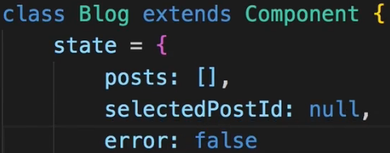 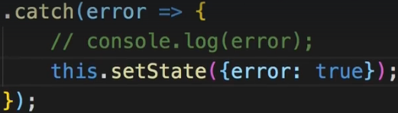  
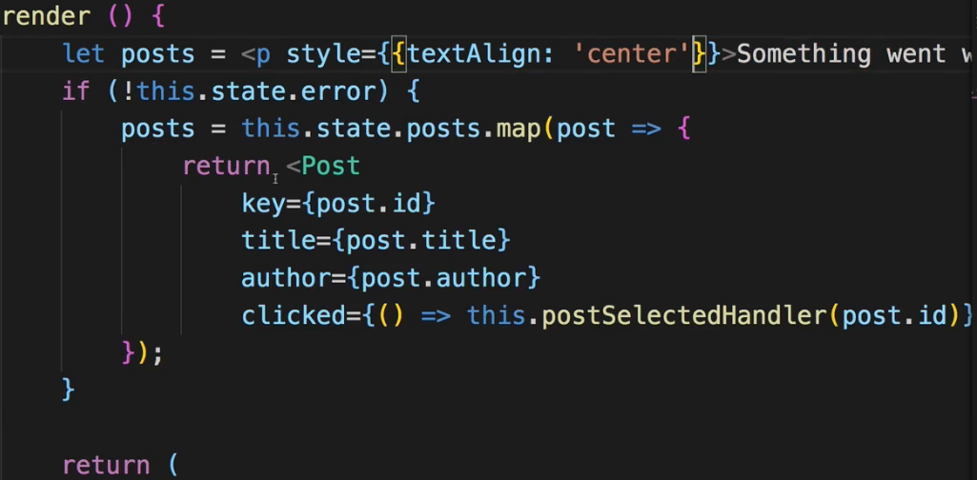  
* So that is a pretty cool way of handling Errors and that is something you definitely also need to be aware of. Things don’t always succeed so you should have a way of catching errors and then doing something with them.  
=> Logging then to the console, sending some Error log request to your own Server to log the Error, and/or show something on the UI to allow the user to still continue or to give instructions what the user should do instead.  
**Adding Interceptors to Execute Code Globally**  
* Handling Error locally in components makes sense a lot because you probably wanna do different things with Errors depending on in which component you’re at.  
* But sometimes in some places you maybe wanna execute some code globally. So no matter which HTTP Request you sent from within which component, you want to do something when that Request gets sent and/or when the Response returns.  
=> You can do this with Axios with the help of so called **INTERCEPTORS**.  
=> These are functions you can define globally which will be executed for every Request leaving your app and every Response returning into it.  
=> This is especially useful for example for setting some common headers like an authorization header maybe or for Responses if you want to log Responses or want to handle Errors globally.  
=> Let’s go to the index.js file because this is the most global file we have in our React app. It’s the file where we actually start our React app by mounting it to the DOM.  
=> **All these Axios imports actually ALL SHARE the same CONFIGURATION**.   
=> **So that is why we can now also use Axios here and access a special `axios.interceptors` object. And again, this will be then shared across all files in your project where you have Axios**.   
=> **So it will affect all Requests sent from anywhere in your app**.  
* The interceptor takes a function as an input which receives the config or the request you could say.  
* **I’m calling it request but it’s just request-config, that’s important to keep in mind**.  
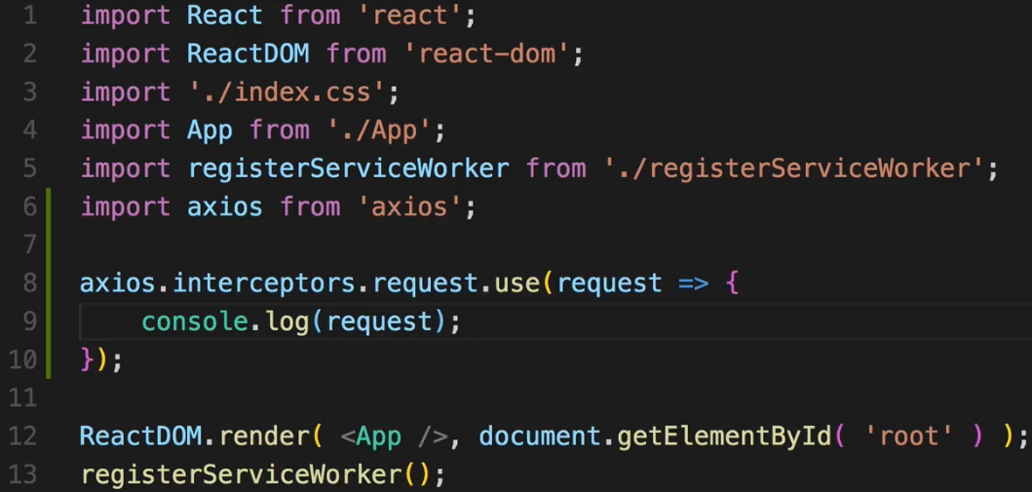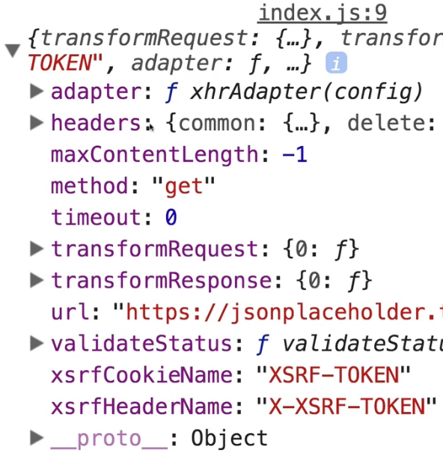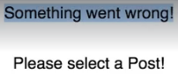  
=> This is the request configuration.  
* Now something went wrong here though because we’re actually blocking our request right now.  
=> **In the interceptor function here you need to ALWAYS RETURN the request or the request config**.   
=> Otherwise you’re blocking the request.  
=> **Now of course you can edit the request config before you return it, that’s the idea behind the interceptor - you can add HEADERS, do stuff like that**.  
* If we click on a post, we get another request config even though it is fired from a different component.  
* Now for that interceptor we can pass a 2nd function besides that request-configuration changing function.   
=> We can add a function which handles any errors.  
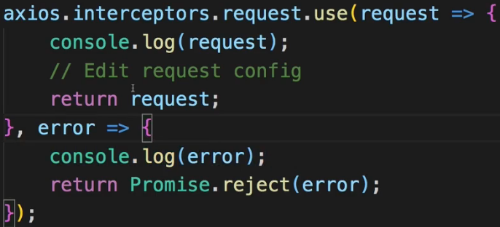  
=> We should also return **Promise.reject(error)** here though so that we still forward it to our Request as we wrote it in the component where we can then handle it again with the .catch() method. This makes sense if you have some local task you wanna do - like show something on the UI, but also globally you want to log it in a log file which you send to a server or something like that.  
* Now if we use the postsssss URL:  
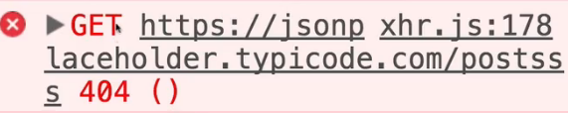 and “Something went wrong!”  
=> But you don’t actually see the console.log() from the Error handler from the interceptor.  
=> The reason for this is that this error here:  
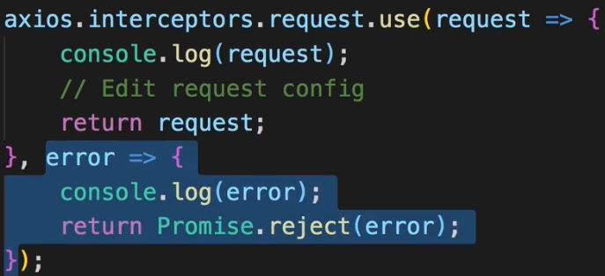   
is related to sending the request - for example if you had no internet connection or something like that, then it should pop up. So if the Request sending fails.  
* **We can also add an interceptor to handle Responses though**.  
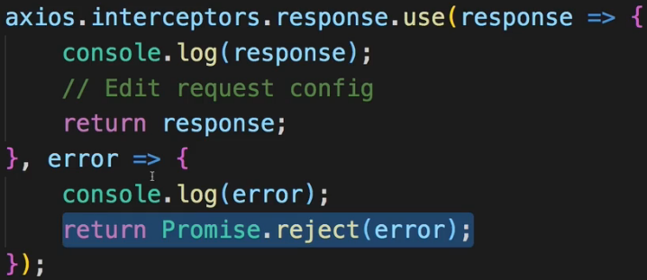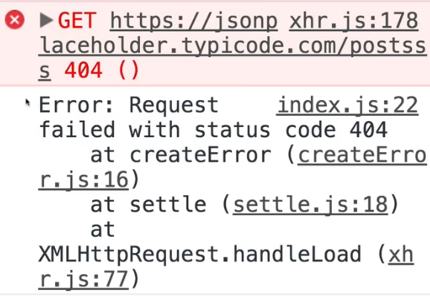  
=> And we also fetch errors and we should also .reject() them here so that we can still handle them in the .catch() block locally in a component.  
=> Now we actually see the console.log() here and we still handle it locally (“Something went wrong!”).  
=> With no errors, we see just the console.log() for the response so this is coming from the interceptor as you can tell by the file name and line number.  
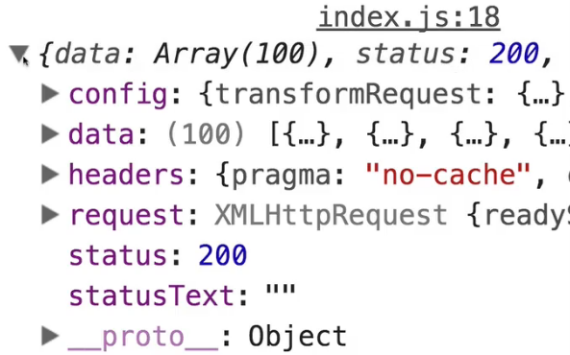  
=> And this is another way of potentially manipulating that Response here or logging it or doing whatever you want.  
=> So being able to define these interceptors can be quite powerful.  
=> **Again a very common usecase is for the request interceptor to add some common headers, for example an authorization header**.  
=> **Though we also have a different way of accessing global Axios configuration**.  
* I’ll show you how this works in the next lecture.  
**Removing Interceptors**  
You learned how to add an interceptor, getting rid of one is also easy. Simply store the reference to the interceptor in a variable and call eject  with that reference as an argument, to remove it  
(more info: <https://github.com/axios/axios#interceptors>):  
var myInterceptor = axios.interceptors.request.use(function () {/*...*/});  
axios.interceptors.request.eject(myInterceptor);

**Setting a Default Global Configuration for Axios**  
* Now sometimes you don’t want to intercept the Request but you want to set up some Global Configuration.   
* Let’s say the URL you’re sending the Requests to in your application is always the same.  
=> So it’s always this:  
  
and then /something. So that starting part is always the same.  
=> So it would be nice if you could cut it out here:  
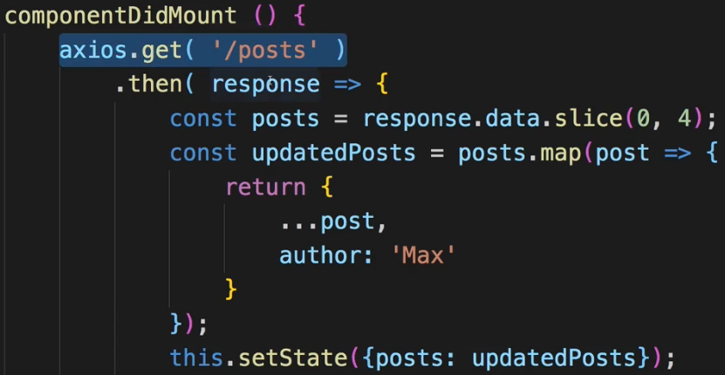  
and just send the Request GET /posts and automatically append this to some common starting URL.  
=> Turns out we can do that.  
=> In the index.js file which is a good place because it runs first, it starts the React app, we can use **axios.defaults.something** => to set up defaults which are true for all Requests which are being sent.  
  
=> And this `baseURL` will now be used as a base URL to which the other paths are then simply appended.  
* Now with that set up we can remove this common part from all the axios methods.  
* And if you go back to the app, you see it still loads, it still works, everything still works fine here because we didn’t really change the way we send the Request but we made it a bit easier for us because of that **Global Configuration**.  
=> Now you’re also not limitted to just settings the `baseURL`.  
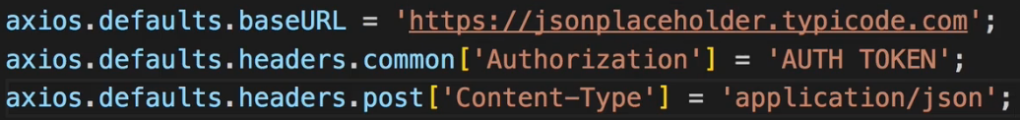  
=> You can also access **axios.defaults**.headers.common and there set a common header - so on that `common` object of “Authorization” - COMMON HEADERS are simply the general headers which are set for all types of Requests and there you could set it to your auth token if you had one or whatever that is.   
=> You can also set headers just for specific Request types. Like for POST Requests ONLY where you maybe want to set the Content-Type that you’re sending to `application/json` - which you don’t need to, that’s the default anyways.  
* So that’s another cool feature of Axios - setting a Default Configuration which will be used application-wide. Helps you to optimize your code quite a lot.  
**Creating and Using Axios Instances**  
* Being able to set a default configuration for Axios is pretty awesome but what if you actually don’t want to use the same baseURL for your entire application but only for parts of it and for other parts you have a different URL. And the same of course for the headers and so on.  
=> In such a case you can do a half-measure by creating a cool feature provided by Axios which is called **Instances** using **axios.create()**.  
=> Let’s create a new file: Axios.js in the `src` folder so on the same level as the index.js.  
=> This method creates an instance of Axios, like a copy of the axios object you could say and you can create multiple such copies.  
=> Now here I will pass a JavaScript object here to configure this and set the baseURL.  
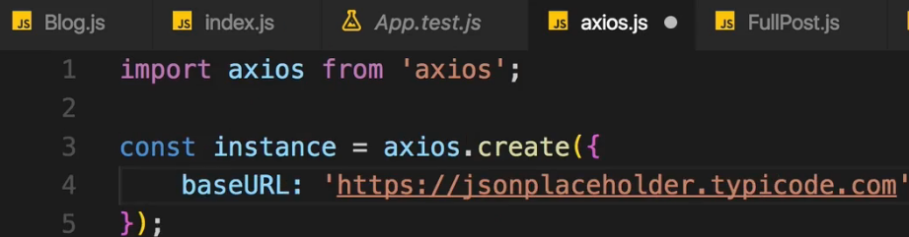  
* Now with that we got 1 part of the whole thing but we’re not finished.  
* We now have our only axios instance and you could of course create multiple instances in different files for different parts of your application.  
* Now by default this instance here will also assume the default setup here in index.js but overwrite anything which it sets up in the instance itself.  
* For example, I could leave the Authorization header being set up in the index.js, but I also want to set it up for my own instance.  
=> So after creating the instance where we can assign the baseURL, now for the headers I replace axios.defaults with **instance.defaults** and now here I can set this to something else to overwrite it for all Requests which are sent using this instance.  
* Now important - we have to export this instance so that we can use it in other files.  
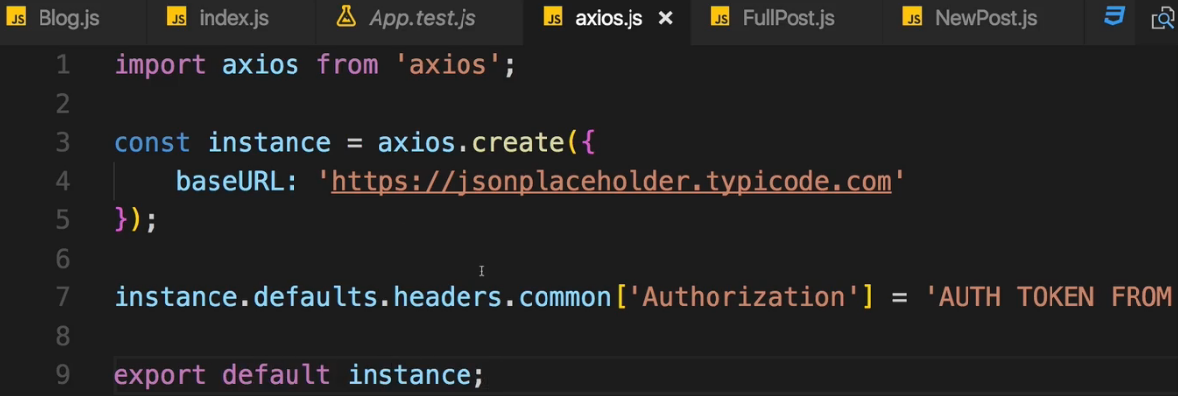 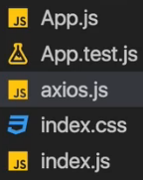  
* Now let’s use it in Blog.js.  
* Now let’s say we don’t import axios from ‘Axios’; package anymore, but we set this axios constant here to our axios instance by pointing to that file where we export that instance as the default.  
* You can of course name it something else then axios. I’ll keep it that way so that I don’t have to adjust the names.  
  
* The application still works fine.  
* Now you will notice 1 thing though - you no longer see the interceptor printing the console.log() for the Request which was sent and the Response which was fetched because the interceptor was set up for the Global `axios` object which we’re not using anymore here in the Blog.js container.  
* If I now try to post something, I get an error because the URL is incorrect because I removed the baseURL from the index.js file - I commented it out and pointed it to my instance which I’m only using in the Blog.js Container though, everywhere else I’m still importing the axios package itself. Now if I comment it back in so that we are able to use the axios package with its defaults but also use our own instance in places where we wanna use it to overwrite some of the settings for the places where we use that instance instead of the default object.  
* And of course you can use **instance.interceptors**.  
* I wanted to should you all this because being able to use instances can give you the flexibility you need in your application. It allows you to control in detail in which part of your application you wanna use which default settings.  
**Axios Docs**: <https://github.com/axios/axios>